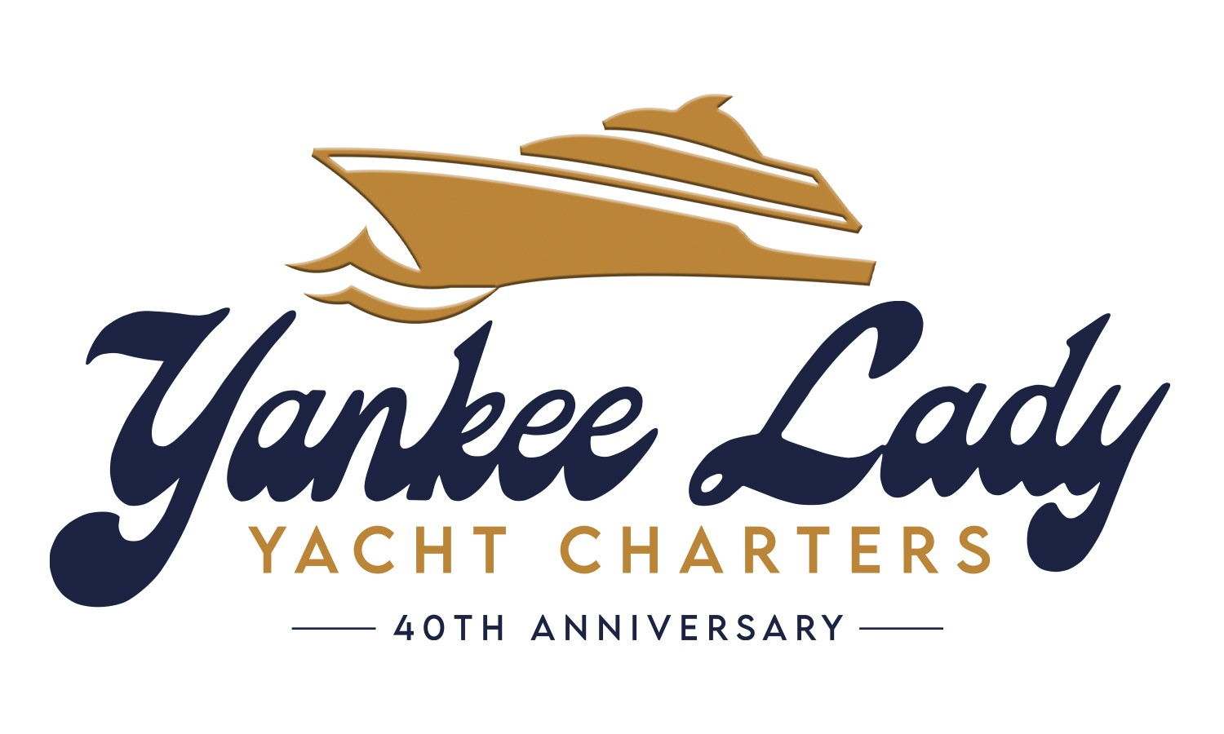
Catering Guidelines and Letter of Release

Guidelines:
Outside caterers are responsible for:
- All food must be prepared off-premises, and for all food-service-related matters.
- The caterer must display a letter-sized sign stating the caterer's name that they are providing the food for this charter
- The caterer is responsible for all Setup of all catering (Yankee Lady will provide tables and linens for one buffet setup)
- The caterer must provide service staff for the buffet.
Yankee Lady staff will be responsible for clearing/bussing the dining areas.
- The caterer must have on board at least one person with food handling certification (Proof to be provided)
- Caterer’s employees shall be appropriately attired and readily identifiable.
- All China, glassware, cutlery, disposables, chafers, serving utensils, charcoal, napkins required for food service must be provided by the caterer unless otherwise stated in the Yankee Lady contract.
- The caterer will provide an onboard meal for Yankee Lady staff and officers
- All premises used by the caterer shall be left in as good condition and repair as before they arrived.
- The caterer may arrive one hour before boarding time.
- The caterer must provide Yankee Lady with a current, valid certificate of insurance for $2 million general liability coverage naming Yankee Lady as an additional insured. (Proof to be provided).
- The caterer is solely responsible for ensuring enough food is available.
- The caterer is solely responsible for providing sufficient staff to set up their food and replenish it.
- A caterer may not sell food on board.
- The caterer may not provide beverages of any kind.
- No open fires are permitted anywhere.
- Yankee Lady may provide water, electricity, and other reasonably necessary utility services to the Caterer.
- The caterer shall remove all unserved food at the end of the function.
- The caterer is responsible for the cost of repairing any damage done to the carpets or other ship property.
- The caterer may not tape, staple, glue, screw, or otherwise attach anything to the walls or ceilings of the boat.

Fees:
There will be an outside catering fee of $1500.00 to cover the cost of bussing, clean-up, and garbage removal.

Additional fees may be incurred for the following:

- Excessive clean-up for spills, etc.: $250
- Use of our galley and ovens: $500
- Use of our cutlery/dishes/napkins: $250
- Use of our chafing dishes and utensils: $250

Signatures:
This letter acknowledges that Yankee Lady Yacht Charters is not responsible for the preparation, service or contracting of the food/foodservice to be provided on Yankee Lady ___, (date)__________, time ____________.

As an outside caterer, ________________________________________, acknowledges that they are responsible for the supply of all food, food related items, as well as food service staff. Yankee Lady is not liable for any illness/situations caused by the food service for the date and time of the charter listed above.

Catering Company Signature:
(Please print name and sign)

Charterer Name and signature:

Date:

